**VIKINDRA REDDY PERAM**

**20AK1A04D1**

**AITS- TIRUPATI**

**1. Fixed LOD Expression with a Different Category:**

Objective:

Create a Fixed LOD expression to calculate the total sales across all sub-categories regardless of any filters applied.

Steps:

1. Identify the dimension or dimensions for which you want to calculate the Fixed LOD expression. In this case, let's use "Sub-Category."
2. Create a Fixed LOD expression for total sales across sub-categories:
   * Right-click on a blank space in the Data pane and select "Create Calculated Field."
   * Name the calculated field (e.g., Total Sales Sub-Category Fixed).
   * Use the below formula
   * { FIXED [Sub-Category] : SUM([Sales]) }

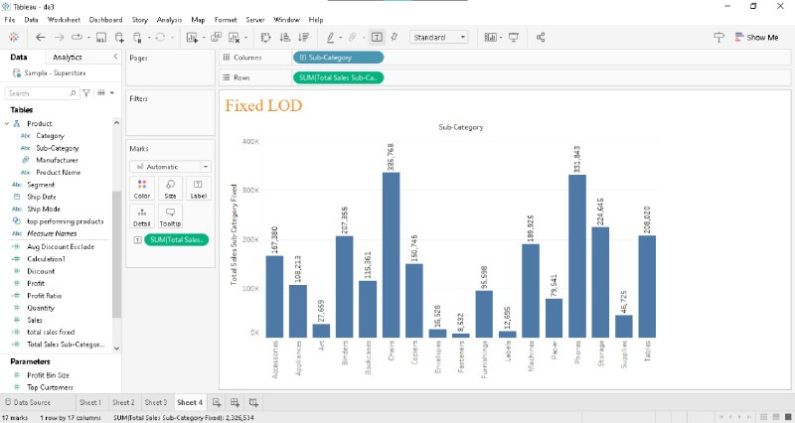

**2. Exclude LOD Expression:**

Objective:

Create an Exclude LOD expression to calculate the average discount across all orders, excluding the "Technology" category.

Steps:

1. Open Tableau and connect to the Superstore dataset.
2. Identify the dimension or dimensions for which you want to calculate the exclude LOD expression. In this case, let's exclude the "Technology" category.
3. Create an Exclude LOD expression for average discount:
   * Right-click on a blank space in the Data pane and select "Create Calculated Field."
   * Name the calculated field (e.g., Avg Discount Exclude).
   * Use the following formula:

{ EXCLUDE [Category]: AVG([Discount]) }

* + Click OK to create the calculated field.

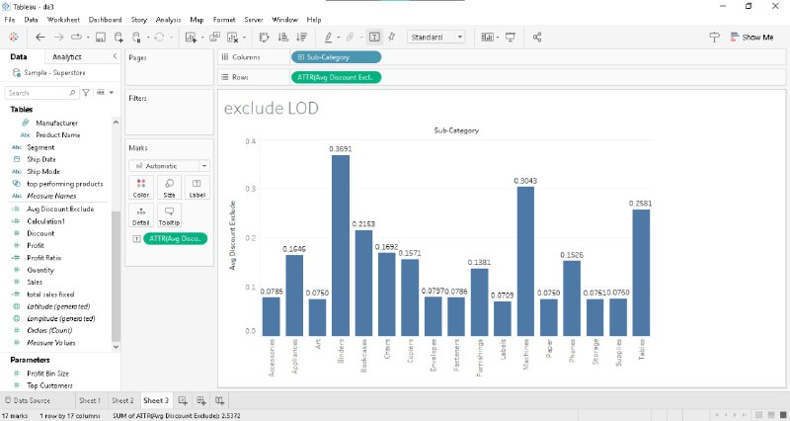

**Map Visualization 1: Symbol Map**

Objective:

Create a symbol map to visualize the distribution of sales across different cities.

Steps:

1. **Connect to your dataset:**
   * Open Tableau and connect to your dataset containing geographical data.
2. **Drag and Drop Latitude and Longitude:**
   * Drag the latitude and longitude dimensions to the Rows and Columns shelves.
3. **Add a Measure for Symbol Size:**
   * Drag the "Sales" measure to the Size shelf. This will determine the size of the symbols on the map.
4. **Convert to Symbol Map:**
   * In the "Show Me" menu, choose the "Symbol Map" option.
5. **Adjust Symbol Properties:**
   * Customize the symbol properties, such as color and shape, based on your preference. You can use the "Color" and "Shape" shelves.
6. **Add Tooltip:**
   * Drag relevant dimensions (e.g., City, Country) to the Tooltip shelf to display additional information when hovering over symbols.

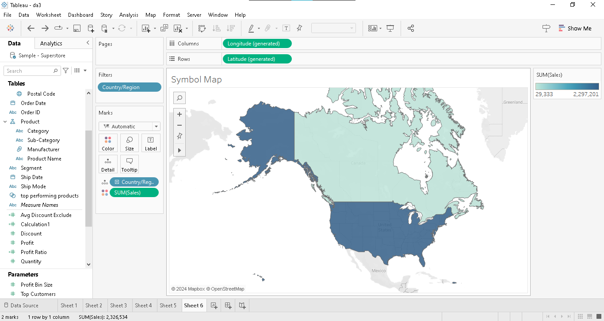

**Map Visualization 2: Filled Map**

1. **Connect to your dataset:**
   * Open Tableau and connect to your dataset containing geographical data.
2. **Drag and Drop Region Dimension:**
   * Drag the dimension representing regions (e.g., Country, State) to the Rows shelf.
3. **Add a Measure for Color Intensity:**
   * Drag the "Sales" measure to the Color shelf. This will determine the color intensity of the filled regions.
4. **Convert to Filled Map:**
   * In the "Show Me" menu, choose the "Filled Map" option.
5. **Customize Color Palette:**
   * Adjust the color palette based on your preference using the "Edit Colors" option.
6. **Add Tooltip:**
   * Drag relevant dimensions (e.g., Country, State) to the Tooltip shelf to display additional information when hovering over regions.

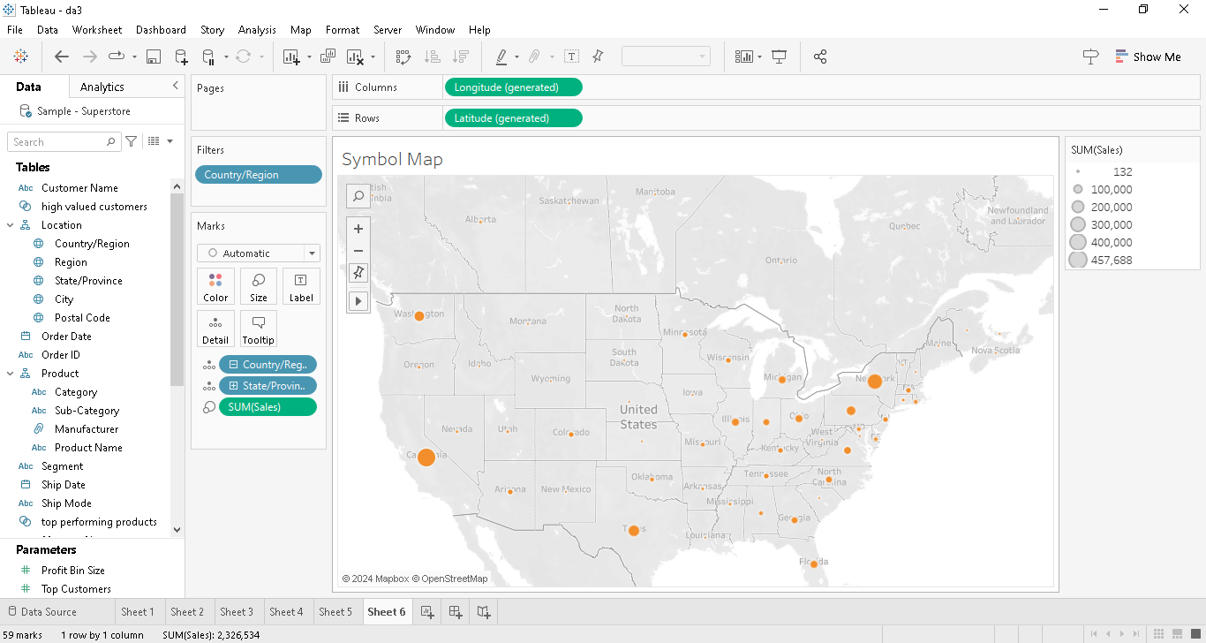

**1: Create a Top N Parameter**

Objective:

Create a parameter to dynamically select the top N sub-categories based on sales.

1. Open your Tableau workbook.
2. Go to the Data pane.
3. Right-click on an empty space and choose "Create Parameter."
4. Name the parameter (e.g., Top N Sub-Categories).
5. Set the Data Type to Integer.
6. Set the Current Value to a default (e.g., 5) and define a range (e.g., 1 to 10).
7. Click OK to create the parameter.

Step 2: Use the Parameter in Calculated Field

Objective:

Create a calculated field to filter sub-categories based on the Top N parameter.

1. Go to the Data pane.
2. Right-click on an empty space and choose "Create Calculated Field."
3. Name the calculated field (e.g., Top N Sub-Categories Filter).
4. Use the following formula:

IF RANK(SUM([Sales])) <= [Top N Sub-Categories] THEN [Sub-Category] END

This formula uses the RANK function to rank sub-categories based on sales and filters only the top N sub-categories.

1. **Click OK to create the calculated field.**

**Step 3: Apply the Filter**

Objective:

Apply the calculated field as a filter to show only the top N sub-categories.

1. Drag the newly created calculated field (Top N Sub-Categories Filter) to the Filters shelf.
2. In the Filter dialog, choose the sub-categories you want to include (based on the calculated field).
3. Click OK to apply the filter.

**Step 4: Utilize Dynamic Dimension Parameters**

Objective:

Create a dynamic parameter to switch between dimensions in your visualization.

1. Go to the Data pane.
2. Right-click on an empty space and choose "Create Parameter."
3. Name the parameter (e.g., Dimension Selector).
4. Set the Data Type to String.
5. In the "List of Values" section, enter the dimensions you want to include (e.g., "Category," "Sub-Category," etc.).
6. Click OK to create the parameter.

Step 5: Use the Dynamic Dimension Parameter

Objective:

Create a calculated field to dynamically switch between dimensions based on the parameter.

1. Go to the Data pane.
2. Right-click on an empty space and choose "Create Calculated Field."
3. Name the calculated field (e.g., Dynamic Dimension).
4. Use the following formula:

CASE [Dimension Selector] WHEN 'Category' THEN [Category] WHEN 'Sub-Category' THEN [Sub-Category] -- Add more cases for additional dimensions if needed END

This formula uses a CASE statement to switch between dimensions based on the selected parameter value.

1. Click OK to create the calculated field.

**Step 6: Use the Dynamic Dimension in Your Visualizations**

Objective:

Use the dynamic dimension calculated field in your visualizations.

1. Replace the existing dimension in your visualizations with the "Dynamic Dimension" calculated field.
2. Change the "Dimension Selector" parameter value to see the dynamic switch between dimensions.

